Apocalypse Card Preview: Phyrexian Arena
Alex Shvartsman
The idea of card advantage has been one of the milestones of Magic strategy since the very creation of the game. One of the first things a new player has to learn when trying to master the game, is that a player with access to more cards is going to win if the game lasts long enough.
Richard Garfield and other Magic designers and playtesters were well aware of this fact. Their mission was to make sure that drawing more than one card per turn would be possible, but not too easy. Throughout the history of the game, R&D has struggled to create "fair" card-drawing engines. They've learned it was almost impossible to make a card-drawing engine that was playable but not overpowered.
Some of the most broken card-drawing engines existed in the innocent time of Alpha through Unlimited. Ancestral Recall and Library of Alexandria are among the very best cards in the game, because they allow a player easy access to additional cards, at a reasonable cost. There are other cards too, such as Braingeyser and its younger sibling Stroke of Genius. Although those cards require a significant mana investment, they still allowed too many cards to be drawn on average.
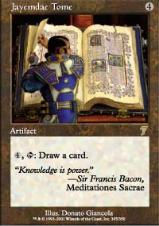
So how much should drawing a card cost you? It seems the fair average is four mana. Jayemdae Tome is one of a few cards that survived from Alpha till present time, remained playable at all times, and highly tournament viable during some periods.
Magic is the game of interchanging resources. You can spend mana to buy cards, use cards to generate mana, even discard cards from your deck to prevent damage. Naturally, game designers have always looked for alternative ways a player can obtain card advantage. One of the more interesting examples is Meditate - it only costs you three mana to draw four cards, but you have to skip a turn too, leaving yourself open to all sorts of nastiness an opponent might come up with.
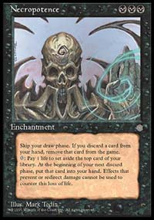
It was not long before a card was created that allowed a player to trade life points for cards. The first such card was printed in Legends. Greed was an enchantment that allowed a player to spend one black mana and two life to draw a card. The cost was simply too high. Although Greed was tournament legal for a long time, having been reprinted in the basic set, it never found its way into winning tournament decks. Wizards's next attempt was far more significant. Ice Age introduced a number of cards we could not imagine the game without today - but the king of them all was Necropotence.
The Skull was a quiet hit. Most players saw it as another junk rare, hardly worth looking at twice. The better deck builders were experimenting with the card however, and soon realized that they had a powerful strategy on their hands. By the time of the very first Pro Tour, Necropotence based decks were a major force, and although a Necro deck did not win the tournament, 1996 Pro Tour-New York helped spread the message: "Card drawing engines do not come much more broken than this."
The problem with Necropotence was similar to the problem with Ancestral Recall. It provided too many cards at a reasonable cost, relatively early in the game. So what if you had to pay life to get them? With access to so many cards, you could play a land every turn, then power a Drain Life with a pair of Dark Rituals to gain the life back. So what if you could not have your draw step? Nevinyrral's Disk was an excellent reset button, allowing you to ditch Necropotence along with whatever your opponent had in play.
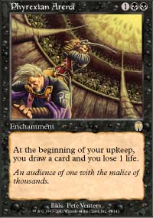
As a self-respecting sinister super-enchantment should, Necropotence just wouldn't go away. R&D liked it. A lot. They kept trying to make it fair. Restricting Ivory Tower, banning Hymn to Tourach, not reprinting Nevinyrral's Disk - none of those things really hindered The Skull. Necropotence had been seen in every kind of deck, from black weenie beatdown, to discard, to control, to combo. Only recently, Necropotence finally got banned from Extended. It still remains among the top Type 1 cards, despite stiff competition.
Ever since Necro proved itself to be too powerful, R&D began the quest to print a "fair" version of the card. Some attempts were indeed fair, but hardly exciting - such as Necrologia. Others were only a tad less powerful than Necropotence. When Mark Rosewater designed Yawgmoth's Bargain, he expected its high casting cost to balance out its ability. Rosewater envisioned Bargain as best played in a white weenie deck with Academy Rector and Scent of Jasmine. Pro players had other ideas. Bargain did get played in combination with Academy Rector. Unfortunately, it was in a combo deck that was anything but fair, and used the generated card advantage to win the game as quickly as turn 3.
It has been a while since a notable Necropotence descendant has been printed. Among an avalanche of exciting new cards in Apocalypse, Phyrexian Arena stands out as a solid candidate to the Necropotence legacy. One of the main reasons Necropotence was so broken was the fact that you could replenish your hand very quickly, effortlessly drawing three cards a turn, if not more. Phyrexian Arena limits you to drawing one extra card per turn. Another twist is that you must draw that extra card. Unlike Necropotence, you cannot stop at one life point and attempt to win with cards you already have.
Phyrexian Arena has several advantages over Necropotence as well. First of all, it does not eliminate the draw step. With this enchantment in play, you are getting two cards every turn. Second, unlike every other life-for-cards variant, Phyrexian Arena is cumulative. Provided you can afford the life points, you can be drawing up to five cards a turn with multiple copies of it in play.
Could a monoblack control deck be viable in the post-Apocalyptic metagame? It largely depends on what the rest of the set looks like, how it will affect other deck archetypes, and what other tools Apocalypse might offer black. There are certainly leads to follow in Seventh Edition - Corrupt and Persecute are perfect cards for an Arena deck.
Strangely enough, the thing I found most intriguing about this card has nothing to do with strategy. Check out the card's artwork. Is that Gerrard delivering a killing blow to Urza? I guess we'll have to wait just a few more days to find out!

